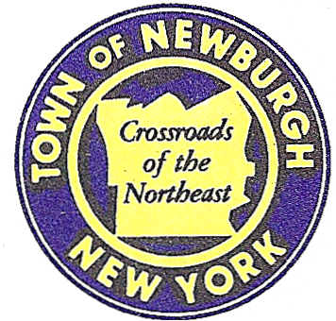

TOWN OF NEWBURGH
_______Crossroads of the Northeast __________________________
OLD TOWN HALL
308 GARDNERTOWN ROAD NEWBURGH, NEW YORK 12550

PLANNING BOARD
JOHN P. EWASUTYN, CHAIRMAN
TELEPHONE 845-564-7804
FAX 845-564-7802
E-MAIL: planningboard@townofnewburgh.org

PLANNING BOARD AGENDA

April 21st, 2016

*PLEASE NOTE: The Planning Board Meeting will start at 7:00 P.M. and all Applicants/Representatives
are to be present at that time. The Meeting will be held in the Meeting Room of Town Hall,
located at 1496 Route 300, Newburgh NY.*

- Bell-Pelella (2016-01) PUBLIC HEARING
65 Lockwood Lane 2 LOT SUBDIVISION
Section 8, Block 1, Lot 4.22
Zone: AR
Rep: Sparaco & Youngblood ,PLLC
P.O. Box 818
18 N. Main St.
Harriman, NY 10926

2. Matrix Business Park at Newburgh (2015-26) AMENDED SITE PLAN
Route 17K
Section 95, Block 1, Lot TBD
(portion of prior Lots 4.12, 54.1, 69.25 & 49.12)
Zone: IB
Rep: Langan Engineering, Environmental,
Surveying & Landscape Architecture
707 Westchester Ave, Suite 304
White Plains, NY 10604

3. Mavis Tire (2015-03) SITE PLAN
1413 Union Avenue
Section 60, Block 3, Lot 40.2
Zone: IB
Rep: Bohler Engineering
5 Computer Drive West, Suite 203
Albany, NY 12205

4. Summit Lane Expansion ( 2015-18) SITE PLAN
Stewart Avenue
Section 97,Block 1,Lot 47 & 48
Zone: R-3
Rep: JMC Planning Engineering Landscape
120 Bedford Road
Armonk, NY 10504

5. 1 Powelton Road (2015-19) SITE PLAN
Section 80, Block 6, Lot 7
Zone: B
Rep: Highlands Architecture, PLLC
3212 Route 9
Cold Spring, NY 10516

